ACADEMIC YEAR 2020-21 ASSOCIATION ACTIVITIES
S. No. | Date | Title of the Event (s) | Chief Guest with Address | No. of Students Participated
1 | 06.02.2021 | Inaugural Function | Mr.V.Ravi  Project Manager  L&T echnology,Services,Mysuru. | 250
2 | 06.03.2021 | Virtual webinar on Industry 4.0,5G Networks, IoT,AI and automation, career guidance. | Mr.V.Viswanathan.  R &D Manager  Nokia, Bangalore | 190
3 | 20.03.2021 | Virtual workshop on skill set for a successful entrepreneur in circuit design | Mr.K.Raguvaran,  Assistant Professor,  Department of ECE/KSRCT | 140
4 | 30.4.2021 | National Level Technical Symposium COMMUNIX’21 | Mr.Mohan Mannappan  Netwrk Development Engineer,  Amazon Services,USA | 240

INAUGURAL FUNCTION
The various association of Department of ECE inaugurated on 06, February, 2021 through Microsoft teams. Dr.P.Kumar, Head of department of ECE welcomed the gathering. Dr.R.Gopalakrishnan, Principal, K.S.Rangasamy College of Technology instructed the students to bring more laurels through innovative projects. Dr.K.B.Jayanthi, Dean, School of Electrical Sciences also delivered the felicitation address. Around 250 participants were participated in the inaugural function. Mr.D. Mugilan, Assistant professor introduced the office bearers of Creative Association for Adducing Communication Engineers (CAFACE), Dr.P.Babu, Professor, introduced the office bearers of Institute of Electronics and Telecommunication Engineers (IETE) and Dr.C Rajasekaran, Professor, introduced the office bearers of Institution of Electrical and Electronics Engineers(IEEE). The chief guest Mr. V.Ravi, Project Manager, L&T technology services, Mysuru shared his experience in the technical field. He gave much more information to the students regarding technical things. He also added about the skills required for placement and possible questions that can be asked during interviews. He also touched his project experience and gave many important details to the students regarding his projects. At the end of the session participants clarified their doubts with Chief Guest. In continuation with the forenoon session, the final year students engaged with their juniors to share their knowledge regarding placement, internship, projects and how to utilize the resources and planning of academic as well as carrier growth during the college days.

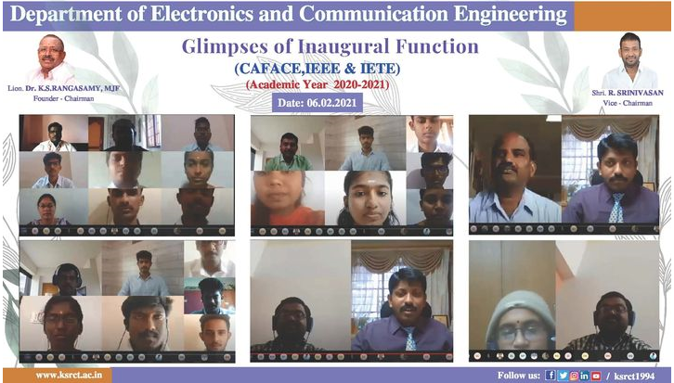
Virtual webinar on
Industry 4.0,5G Networks, IoT, AI and automation, career guidance.

The virtual webinar on “Industry 4.0,5G Networks, IoT, AI and automation, career guidance.” was organized by Department of Electronics and Communication Engineering and CAFACE Association and IETE & IEEE students’ chapter on 06.03.2021. Mr.V.Viswanathan. R&D Manager Nokia, Bangalore was the recourse person. He started with industrial revolutions, future of 5G technology, research area focused on the dynamic spectrum sharing and interfacing the sensors and cloud usage etc.. Finally trigger the spark among the student’s community about industry expectation and how to bridge the gap.

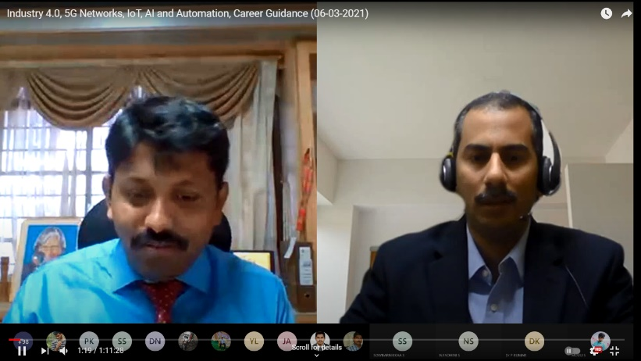
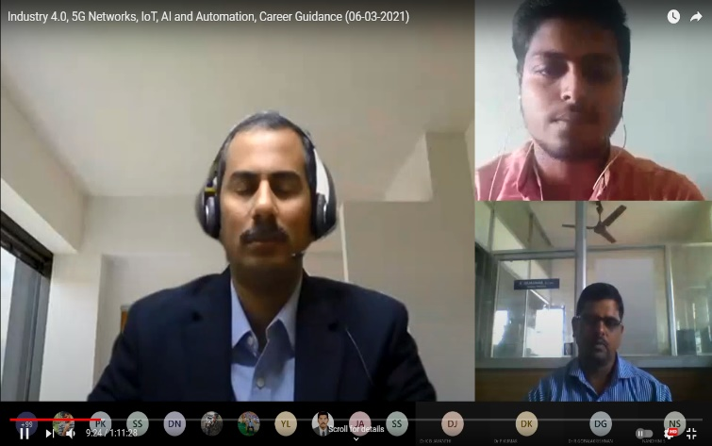

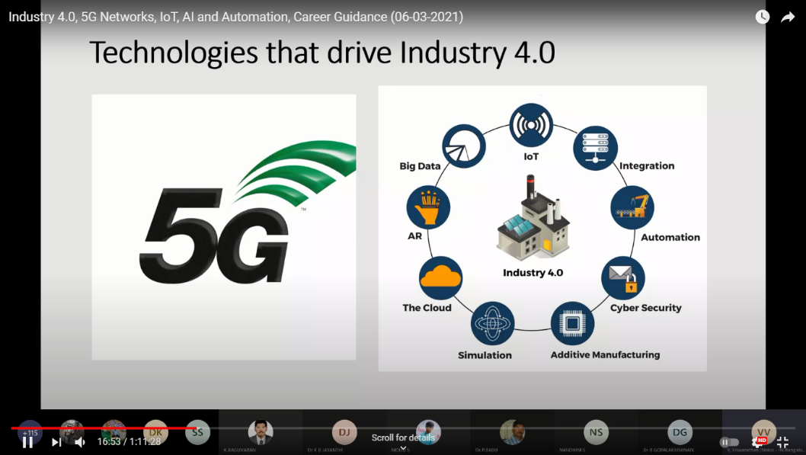

Virtual workshop on
Skill set for a successful entrepreneur in circuit design

The virtual webinar on “Skill set for a successful entrepreneur in circuit design.” was organized by Department of Electronics and Communication Engineering and CAFACE Association and IETE & IEEE students’ chapter on 20.03.2021. Mr.K.Raguvaran, Assistant Professor, Department of ECE/KSRCT was the recourse person. The idea of this virtual workshop was to showcase the features of latest Altium Designer tool for the benefit of students to become an entrepreneur. During the session explained step by step working process of circuit design, component selections and interconnection between the devices. At the end simple PCB design was done with the help of Altium software. This practical exposure helps the students to design own circuitry in future and become an entrepreneur.

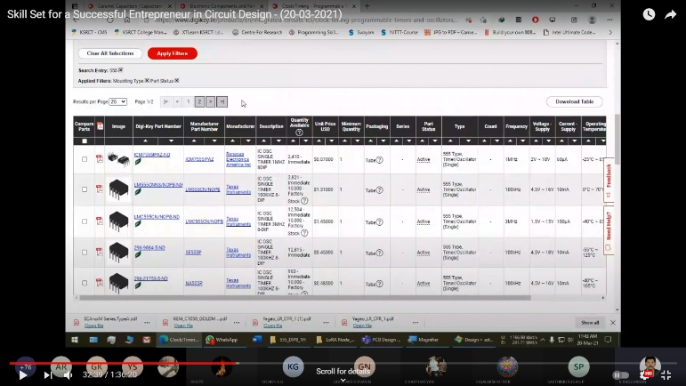
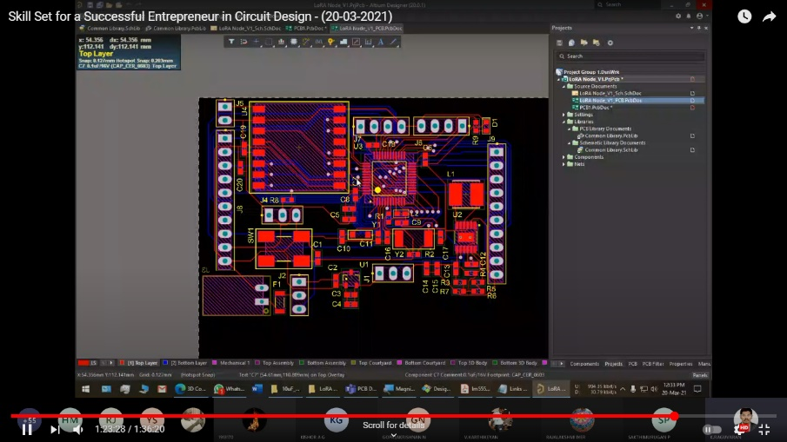
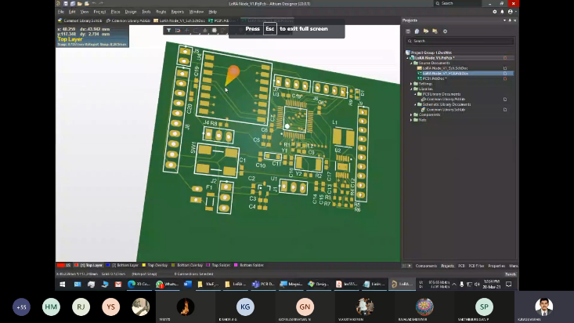

National Level Technical Symposium COMMUNIX’21
“COMMUNIX 2k21”, a National level technical symposium was organized by the department of Electronics and Communication Engineering, K. S. Rangasamy College of Technology starts with the Inaugural function. The resource person was Mr. Mohan Mannappan, Network Development Engineer, Amazon Services, USA. The session started with a divine prayer song. The welcome address was given by the final year student, Mr.C.Srinivas. . The Head of the department Dr.P.Kumar, addressed the gathering. Dr.R.Gopalakrishnan ,Principal, K.S.Rangasamy college of technology felicitated the gathering. Dr.K.B.Jayanthi , Dean , School of electrical science also felicitated the meeting. Introduction to chief guest was given by Ms. P. Ishwarya, final year. The chief guest shared his experience in the technical field. He gave us so much information regarding Cloud computing and Networking. He encouraged us to learn programming languages. He gave many inputs regarding the skills required to get placed. He also added to develop our communication skills. Participants clarified their doubts with the chief guest. The session came to an end by proposing vote of thanks by the second year student Ms.S.Nandhini. The session was knowledgeable and we gained lot of information through this session.
After the session various technical events such as paper presentation, project presentation and circuit debugging was conducted. Students from various colleges participated enthusiastically. Different slots were allotted for the participants based on their domains. We received around 80 papers out of 60 shortlisted and 20 projects were received. Non-technical events such as connections, memes and photography was conducted. The winners were announced on the next day of the event. The symposium was successfully organized by the student coordinators with the guidance of faculty coordinators.
